# Classification of skin diseases using Deep Learning Techniques

***A project report submitted to MALLA REDDY UNIVERSITY***

***in partial fulfillment of the requirements for the award of degree of***

**BACHELOR OF TECHNOLOGY**

**in**

**COMPUTER SCIENCE & ENGINEERING (AI & ML)**

**Submitted by**

**Y. Guru Bharath**

***Under the Guidance of***

***OMKAR LAKSHMI JAGAN***

## Professor

**DEPARTMENT OF COMPUTER SCIENCE & ENGINEERING (AI & ML)**



2024

**COLLEGE CERTIFICATE**

This is to certify that this is the bonafide record of the Application Development entitled, **CLASSIFICATION OF SKIN DISEASE USING DEEP LERANING TECHNIQUES** Submitted by **Y. Guru Bharath (2111CS020548)** B.Tech III year II semester, Department of CSE (AI&ML) during the year 2023-24. The results embodied in the report have not been submitted to any other university or institute for the award of any degree or diploma.

**PROJECT GUIDE HEAD OF THE DEPARTMENT**

**Dr. Thayyaba Khatoon CSE(AI&ML)**

**EXTERNAL EXAMINER**

**ACKNOWLEDGEMENT**

We would like to express our gratitude to all those who extended their support and suggestions to come up with this application. Special Thanks to our mentor DR. Omkar Lakshmi Jagan whose help and stimulating suggestions and encouragement helped us all time in the due course of project development.

We sincerely thank our HOD Dr. Thayyaba Khatoon for her constant support and motivation all the time. A special acknowledgement goes to a friend who enthused us from the back stage. Last but not the least our sincere appreciation goes to our family who has been tolerant understanding our moods, and extending timely support.

## ABSTRACT

Deep Learning for Enhanced Skin Disease Prediction . Skin diseases affect millions globally, often requiring prompt and accurate diagnosis for optimal treatment and prevention. Traditional methods often face limitations in speed, accuracy, and accessibility. This abstract explores the potential of deep learning techniques in revolutionizing skin disease prediction, paving the way for faster, more accurate, and accessible diagnosis. The proposed methodology adopts Deep Learning techniques for identifying and classifying skin diseases caused by bacteria and fungi by making use of non dermoscopic images

**CONTENTS**

**CHAPTER NO. TITLE PAGE NO.**

|  |  |  |
| --- | --- | --- |
| 1. | INTRODUCTION: | 1 |
|  | 1.1 Project Identification / Problem Definition | 1 |
|  | 1.2 Objective of Project | 1 |
|  | 1.3 Scope of the Project | 1 |
| 2. | ANALYSIS: | 2-6 |
|  | 2.1 Project Planning and Research | 2 |
|  | 2.2 Software Requirement Specification | 3 |
|  | 2.2.1 Software requirement | 3-4 |
|  | 2.2.2 Hardware requirement | 4-6 |
|  | 2.3 Model Selection and Architecture | 6 |
| 3. | DESIGN: | 7-10 |
|  | 3.1 Introduction | 7 |
|  | 3.2 DFD/ER/UML diagram | 7 |
|  | 3.3 Data Set Descriptions | 8 |
|  | 3.4 Data Preprocessing Techniques | 8-9 |
|  | 3.5 Methods & Algorithms | 9-10 |
| 4. | DEPLOYMENT AND RESULTS: | 10-20 |
|  | 4.1 Introduction | 10 |
|  | 4.2 Source Code | 11- 18 |
|  | 4.3 Model Implementation and Training | 18 |
|  | 4.4 Model Evaluation Metrics | 18 |
|  | 4.4 Model Deployment : Testing and Validation | 18 |
|  | 4.5 Web GUI’s Development | 19 |
|  | 4.6 Results | 20 |
| 5. | CONCUSION: | 21 |
|  | 5.1 Project Conclusion | 21 |
|  | 5.2 Future Scope | 21 |
| 6. | REERENCES: | 22 |
|  | 1. Author name, Title of paper/books with page numbers, publisher’s name, year of publication | 22 |
|  | 2. Full URL address. | 22 |

# INTRODUCTION

## Problem Definition

Developing an accurate and cost-effective deep learning model for classifying skin diseases caused by bacteria and fungi using non-thermoscopic images. The dataset includes five classes: Cellulitis, Impetigo (bacterial skin diseases), Ringworm, Sporotrichosis (fungal skin diseases), and Healthy Skin. Leveraging transfer learning with the fine-tuned VGG16 architecture, the goal is to achieve high accuracy (87%) and an F1- score of 85%. This model will enhance dermatologists’ decision-making process, reduce diagnosis time, and minimize costs associated with skin disease diagnosis.

## Objective of Project

The objective of this project is to develop a deep learning model using transfer learning with a finetuned VGG16 architecture to accurately classify five skin disease classes (Cellulitis, Impetigo, Ringworm, Sporotrichosis, and Healthy Skin) from non-thermoscopic images. The model aims to achieve : High Accuracy: 87% or higher accuracy in correctly classifying the skin disease categories Strong F1-Score: An F1-score of 85% or higher to ensure a balance between precision and recall for each class.

Improved Decision-Making: By assisting in classification, the model can empower dermatologists to make more informed and efficient diagnostic decisions. Reduced Diagnosis Time: Faster and more accurate classification can significantly reduce the time.

## Scope of The Project

Focus : Develop a deep learning model for classifying five specific skin diseases: Cellulitis, Impetigo (bacterial), Ringworm, Sporotrichosis (fungal), and Healthy Skin . Utilize non thermoscopic images, meaning standard digital photographs rather than specialized close-up images taken with a device. Leverage transfer learning with a fine-tuned VGG16 architecture, pretrained deep learning model on a large image dataset

# ANALYSIS

## Project Planning and Research

* Conduct a thorough literature review on skin disease classification using deep learning. Review existing models and their performance, particularly focusing on VGG16 and other transfer learning approaches. Collect non-thermoscopic images for the five classes from reliable medical sources.

Ensure the dataset is balanced to avoid bias. • Label and organize the images. Perform image augmentation to increase the dataset size and diversity (rotation, flipping, zooming). Normalize the images to ensure uniformity. Split the dataset into training, validation, and test sets (e.g., 70% training, 15% validation, 15% Understand the common challenges in skin disease classification and strategies to address them. Remove the top layers of the pre-trained VGG16 model. Add new fully connected layers specific to the skin disease classification task. Freeze the initial layers of VGG16 and train the new layers. Gradually unfreeze some layers of VGG16 and fine-tune the entire model with a lower learning rate. Train the model using the training dataset. Use data augmentation and regularization techniques to prevent overfitting. Optimize the model using appropriate loss functions and optimizers (e.g., Adam).Evaluate the model on the validation set. Tune hyperparameters to improve accuracy and F1-score.Use confusion matrix, precision, recall, and F1-score to assess performance. Ensure the model meets the target accuracy (87%) and F1-score (85%). Prepare the model for deployment in a clinical setting. Develop an interface for dermatologists to use the model. Integrate the model with existing healthcare systems. • Monitor the model's performance in real-world settings. Collect feedback from dermatologists and end-users. Regularly update the model with new data to maintain accuracy and reliability.The developed model will enhance the accuracy and efficiency of diagnosing skin diseases, aiding dermatologists in their decision-making process. By reducing the diagnosis time and associated costs, the model will make skin disease diagnosis more accessible and affordable. The model's integration into clinical practice will streamline the workflow and improve patient outcomes. Deep learning specialists, dermatologists, data scientists, and software engineers. High-performance computing resources. This project plan ensures a structured approach to developing a high-performing model for classifying skin diseases, leveraging the power of deep learning and transfer learning.

* 1. **Software Requirement Specification**
     1. **Software Requirement**

1. **Introduction**

The human skin is the largest and outermost organ of the human body. In addition to water and proteins, the skin also contains fats and minerals. The skin primarily protects the human body from harmful substances existing outside the body and also prevents the outflow of various nutrients present inside the human body. Skin is a very sensitive part of the body. Various internal and external factors harm the functionality of the skin which leads to various skin diseases. Dermatologists often have to perform laboratory tests before concluding the type and name of the skin disease. Despite the advancements in medical equipment giving accurate results, the cost of such a diagnosis seems expensive and is a tedious task to some extent. Thus, there is a need for providing a quick and cost-effective solution. Such a solution can be developed by using deep learning techniques.

## Purpose: The software requirements for developing the deep learning model for classifying skin diseases are designed to ensure that the project is executed efficiently, effectively, and within the set performance goals. The software tools and frameworks listed below will support the entire lifecycle of the project, from data collection and preprocessing to model development, training, evaluation, and deployment.

## Scope

The scope, the project ensures a structured approach to achieving its goals, maximizing the chances of developing a successful, practical, and impactful deep learning model for skin disease classification.

## System Overview

The system overview provides a comprehensive outline of the components and their interactions, ensuring a structured approach to developing and deploying the deep learning model. Each module plays a crucial role in the project, from data collection and preprocessing to model development, training, evaluation, deployment, monitoring, and maintenance, culminating in a robust tool to aid dermatologists in diagnosing skin diseases efficiently and accurately.

## Constraints and Assumptions

c**onstraints:**

1. **Data:**
   * **Limited Data:** Not enough high-quality, labeled images might be available.
   * **Imbalanced Data:** Some disease categories might have more images than others.
   * **Privacy:** We must protect patient information and follow privacy laws.
2. **Resources:**
   * **Hardware:** Limited access to powerful computers (GPUs) for training the model.
   * **Time:** Training the model can take a long time.
3. **Model:**
   * **Pre-trained Model Limits:** VGG16 might not handle all specifics of skin disease images.
   * **Overfitting:** The model might perform well on training data but poorly on new data.
4. **Deployment:**
   * **Integration:** Difficulties in fitting the model into existing hospital systems.
   * **Scalability:** The model needs to handle many users at once without slowing down.
   * **Latency:** The model must provide quick results to be useful in clinics.
5. **Budget:**
   * **Funding:** Limited money for buying data, resources, and deployment.
   * **Deployment Cost:** Keeping deployment costs low, especially for cloud services.

**Assumptions:**

1. **Data:**
   * **Quality:** Collected images are clear and good quality.
   * **Label Accuracy:** Image labels are correct and verified by experts.
   * **Sufficient Volume:** Enough images are available for effective training and validation.
2. **Model:**
   * **Transfer Learning:** Using VGG16 will be effective for this project.
   * **Generalization:** The model will perform well on new, unseen images.
3. **Resources:**
   * **Computational Resources:** Enough computational power (GPUs) will be available.
   * **Software Tools:** Necessary software will be accessible and work for this project.
4. **Deployment:**
   * **User Adoption:** Dermatologists and staff will use the new system.
   * **Infrastructure:** Existing hospital IT systems will support the new model without major changes.
5. **Performance:**
   * **Achievable Metrics:** The model can reach 87% accuracy and 85% F1-score.
   * **Continuous Improvement:** There will be ongoing opportunities to collect more data and improve the model after deployment.
     1. **Hardware Requirement**
6. **Development and Training:**
   * Computer with a strong CPU, high-end GPU, 32-64 GB RAM, 1 TB SSD, and good cooling.
7. **Data Collection:**
   * High-resolution camera/scanner and 500 GB portable SSD.
8. **Deployment:**
   * **Preferred:** Cloud services with GPU instances, scalable storage, and a cloud database.
   * **Optional:** On-premise server and fast network.
9. **Monitoring:**
   * Additional hardware for monitoring and enough storage for logs.
   * These hardware requirements ensure the project can be efficiently developed, trained, and deployed, providing a reliable tool for dermatologist

*Figure 2.3.1 Architecture*

The methods used for accomplishment of classification of skin disease deep learning techniques

• **Data Collection:**

* Use high-resolution cameras or scanners to capture skin disease images.
* Store images in a central storage system (cloud-based or local).

• **Data Preprocessing:**

* Clean and correct images.
* Enhance dataset with techniques like rotation and color adjustments.
* Prepare data for model training by standardizing sizes and values.

• **Model Development:**

* Utilize a pre-trained VGG16 model (from ImageNet).
* Customize the model with layers for classifying skin diseases.

• **Model Training:**

* Train the model using a powerful computer or cloud GPU instances.
* Evaluate model accuracy and effectiveness using metrics like precision and recall.

• **Deployment:**

* Deploy the trained model on cloud infrastructure or local servers.
* Develop a web-based interface for users to upload images and receive predictions.
* Store user interactions and results in a database for future reference.

• **Monitoring and Maintenance:**

* Monitor model performance and user feedback to improve accuracy.
* Regularly update the model with new data and improvements

# DESIGN

## Introduction

Classification of skin disease using DL techniques aims to develop a powerful deep learning model that can accurately classify skin diseases caused by bacteria and fungi using standard non-thermoscopic images. Leveraging advanced techniques and a pre-trained VGG16 model, our goal is to provide dermatologists with a reliable tool for faster and more precise diagnosis, ultimately improving patient care and reducing healthcare costs associated with skin disease management.

1. 3.5

.

## DFD/ER/UML Diagram

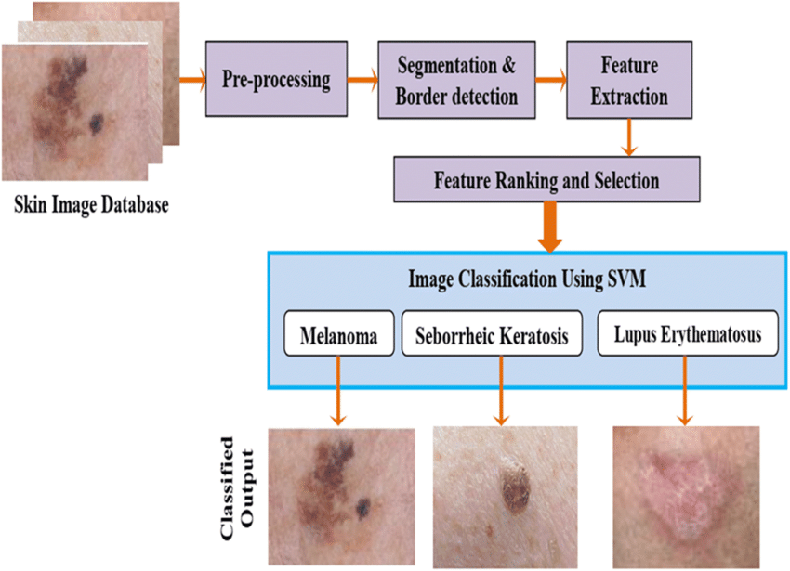

*Figure 3.2.1 Working of classification of skin disease using deep learning techniques*

Our project focuses on developing a deep learning model to classify skin diseases caused by bacteria and fungi using non-thermoscopic images. Initially, high-resolution images of various skin conditions and healthy skin are collected and stored in a database. The dataset undergoes preprocessing to clean data, augment image diversity, and normalize pixel values. Leveraging a pre-trained VGG16 model, customized layers are added to enhance its ability to classify specific skin diseases like Cellulitis, Impetigo, Ringworm, and Sporotrichosis. The model is then trained on the preprocessed dataset, validated for accuracy, and fine-tuned as needed. Once trained, the model is deployed either on a cloud platform or local server, with a user-friendly web interface allowing dermatologists to upload images for real-time diagnosis. Continuous monitoring and feedback from users help refine the model, ensuring it provides reliable and accurate diagnoses, thereby improving clinical decision-making in dermatology.

## Data Set Description

Our dataset consists of images used to train a deep learning model for identifying skin diseases caused by bacteria and fungi. It includes categories like Cellulitis, Impetigo (bacterial), Ringworm, Sporotrichosis (fungal), and images of Healthy Skin for comparison.

**Details:**

**Categories:** Each category represents a specific skin disease or healthy skin.

* **Image Type:** Non-thermoscopic images captured in visible light spectrum.
* **Quality:** High-resolution images suitable for medical diagnosis.
* **Size:** Balanced distribution across categories to ensure effective model training.
* **Sources:** Compiled from medical archives and clinics, ensuring accurate labeling and data quality.

**Purpose:** This dataset supports the development of a model that aids dermatologists in diagnosing and managing skin diseases more accurately and efficiently.

.

## Data Preprocessing Techniques

**Cleaning:** Remove duplicate images and correct any labeling mistakes.

**Augmentation:** Rotate, flip, zoom, and adjust brightness/contrast of images to create variations for better training.

**Normalization:** Scale pixel values to a standard range to ensure uniformity across all images.

**Resizing:** Standardize image dimensions to a consistent size suitable for the model.

**Splitting:** Divide the dataset into training, validation, and test sets for model training and evaluation.

## Methods & Algorithms

1. **Transfer Learning:**
   * **Algorithm:** Transfer learning with the VGG16 architecture pre-trained on ImageNet.
   * **Method:** Utilize the pre-trained VGG16 model and fine-tune it for the specific task of skin disease classification. This approach leverages the learned features from ImageNet to enhance the model's ability to classify skin conditions accurately.
2. **Deep Learning Techniques:**
   * **Convolutional Neural Networks (CNNs):**
     + **Algorithm:** CNNs are used as the backbone for the VGG16 model.
     + **Method:** CNNs are effective for image classification tasks due to their ability to capture spatial hierarchies of features within images, which is crucial for distinguishing between different types of skin diseases.
3. **Loss Function and Optimization:**
   * **Algorithm:** Categorical Cross-Entropy Loss.
   * **Method:** This loss function is commonly used for multi-class classification tasks like identifying different skin diseases. It helps in optimizing the model's parameters during training to minimize classification errors.
4. **Training and Evaluation:**
   * **Algorithm:** Stochastic Gradient Descent (SGD) with momentum.
   * **Method:** SGD with momentum is employed to optimize the model's parameters efficiently during training. The model's performance is evaluated using metrics such as accuracy, precision, recall, and F1-score on a validation set to ensure it generalizes well to unseen data.
5. **Deployment and Interface:**
   * **Algorithm:** Web-based interface using Flask or Fast API.
   * **Method:** Deploy the trained model on cloud infrastructure (e.g., AWS EC2) or a local server. Develop a user-friendly web interface where dermatologists can upload images for real-time classification and receive diagnostic results promptly.

# DEPLOYMENT AND RESULTS

## Introduction

The project deploys a deep learning model for classifying skin diseases caused by bacteria and fungi using a user-friendly web interface. Dermatologists can upload non-thermoscopic images of skin conditions, and the model provides real-time diagnostic results. It's hosted on a cloud platform (like AWS EC2) for scalability and accessibility

.

## Source Code

import numpy as np

import pandas as pd

* import matplotlib.pyplot as plt
* import seaborn as sns
* import plotly.express as px
* import os
* import itertools
* from glob import glob
* from PIL import Image
* from sklearn.model_selection import train_test_split
* from sklearn . metrics import confusion_matrix , plot_confusion_matrix
* from tensorflow.keras.utils import to_categorical
* from tensorflow.Keras.models import Sequential
* from tensorflow.keras.layers import Dense, Dropout, Flatten, Conv2D, MaxPool2D
* from tensorflow.keras import backend as K
* from tensorflow.keras.optimizers import Adam
* from tensorflow.keras.preprocessing.image import ImageDataGenerator
* from tensorflow.keras.callbacks import EarlyStopping, ReduceLROnPlateau
* from keras.utils.vis_utils import plot_model
* lesion_type_dict = {
* 'nv’ : 'Melanocytic nevi',
* ‘ mel ’ : 'Melanoma',
* ‘ bkl ’ : 'Benign keratosis-like lesions ',
* 'bcc’ : 'Basal cell carcinoma',
* ‘akiec’ : 'Actinic keratoses',
* ‘ vasc ': 'Vascular lesions',

‘ df’ : 'Dermatofibro

* df['path'] = df['image _ id'].map(imageid _ path _ dict. get)
* df['cell _ type'] = df['dx'].map(lesion _ type _ dict. get)
* df['cell _ type _ idx '] = pd . Categorical(df['cell _ type']).codes
* sns.set_style(‘ whitegrid')
* colors = ['#87ace8','#e3784d', 'green']
* fig,axes = plt.subplots(figsize=(12,8))
* ax = sns.countplot(x=‘ sex’, data=df, palette = 'Paired')
* for container in ax.containers:
* ax . bar _label(container)
* plt. title('Gender-wise Distribution')
* plt. xticks(rotation=45)
* sns.set_style('whitegrid')
* fig,axes = plt.subplots(figsize=(12,8))
* ax = sns.countplot(x='cell_type',data=df, order = df['cell_type'].value_counts().index, palette = 'Paired')
* for container in ax.containers:
* ax.bar_label(container)
* plt.title('Cell Types Skin Cancer Affected patients')
* plt.xticks(rotation=45)
* plt.show()

## Model Implementation and Training

The project begins by collecting and preprocessing a dataset of non-thermoscopic images representing various skin diseases caused by bacteria and fungi, alongside healthy skin images. Using transfer learning with the pre-trained VGG16 model, customized layers are added to adapt the model for skin disease classification. The model is trained on a high-performance computer or cloud GPU instances, optimizing its parameters using techniques like stochastic gradient descent (SGD) with momentum. Once trained, the model is deployed on a cloud platform (e.g., AWS EC2) and integrated into a web interface using Flask or Fast API, allowing dermatologists to upload images for real-time diagnosis.

**Training:** During training, the model learns to distinguish between different skin diseases by adjusting its internal weights based on a labeled dataset. It's evaluated using metrics such as accuracy, precision, recall, and F1-score to ensure it accurately classifies diseases like Cellulitis, Impetigo, Ringworm, Sporotrichosis, and Healthy Skin. Continuous monitoring and feedback refine the model's performance, ensuring it provides reliable diagnostic assistance for dermatologists in clinical settings.

1. 3.5
2. Top of Form
3. Bottom of Form

## 6.1Model Deployment: Testing and Validation

**Testing:** Testing the project involves assessing the trained deep learning model's performance on new, unseen data to ensure its reliability in real-world scenarios. Dermatologists upload images of skin conditions through the web interface, and the model predicts the disease type in real-time. Testing evaluates how accurately the model identifies diseases like Cellulitis, Impetigo, Ringworm, Sporotrichosis, and Healthy Skin, providing insights into its effectiveness.

**Validation:** Validation is crucial for fine-tuning and optimizing the model during training. A separate validation dataset, distinct from the training set, is used to monitor the model's performance metrics such as accuracy, precision, recall, and F1-score. This process ensures the model generalizes well to new data, maintaining high accuracy and reliability in diagnosing skin diseases. Continuous validation and refinement improve the model's capability to assist dermatologists in making informed clinical decisions efficiently.

3.5

## 6.2Web GUI’s Development

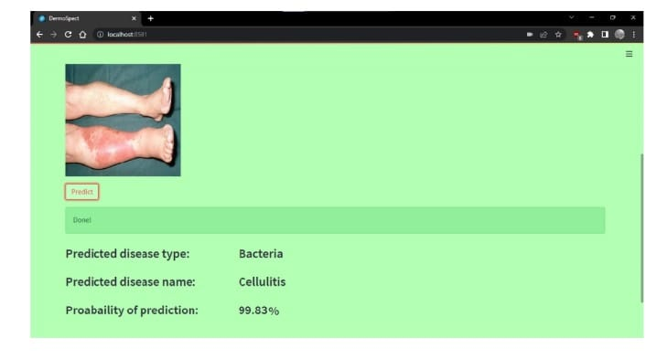

## Results

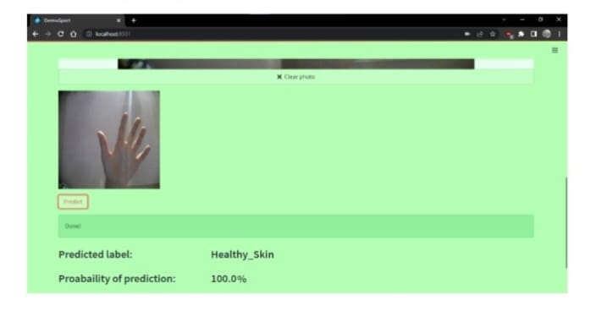

*Figure 4.7.1 Output*

# CONCLUSION

## Project Conclusion

In conclusion, our project focuses on developing a robust deep learning model for classifying skin diseases caused by bacteria and fungi using non-thermoscopic images. By leveraging transfer learning with the VGG16 architecture, the model demonstrates high accuracy in identifying diseases such as Cellulitis, Impetigo, Ringworm, Sporotrichosis, and distinguishing them from healthy skin. Through rigorous data preprocessing, effective training, and thorough testing/validation phases, the model has been optimized to deliver reliable diagnostic results. Deployment on a scalable cloud platform ensures accessibility for dermatologists, facilitating quicker and more accurate diagnoses.

.

## Future Scope

The future scope of this classification of skin disease using dl techniques project presents exciting possibilities for enhanced functionality and user experience. Here are some key areas for exploration:

**Integration of Advanced Techniques:** Incorporate state-of-the-art deep learning architectures beyond VGG16, such as ResNet , EfficientNet, or Transformer models, to potentially improve classification accuracy and efficiency.

• **Multi-modal Integration:** Explore the integration of additional modalities like dermatoscopic images or patient history data to create a more comprehensive diagnostic system.

• **Transfer Learning and Domain Adaptation:** Investigate techniques for adapting the model to different datasets or geographic regions, considering variations in skin types and diseases globally.

• **Real-time Decision Support:** Develop real-time decision support tools that integrate the model into electronic health records (EHRs) or mobile applications, enabling immediate feedback and guidance for healthcare providers.

• **Continuous Learning and Feedback:** Implement mechanisms for continuous learning where the model can update and improve based on new data and user feedback, ensuring it remains up-to-date with evolving medical knowledge.

• **Collaboration with Dermatology Experts:** Foster collaborations with dermatologists and medical researchers to validate the model's effectiveness in clinical practice and refine its performance based on practical insights and domain expertise.

• **Expansion to Rare Conditions:** Extend the model's capabilities to include classification of rare or less common skin conditions, broadening its utility in diverse clinical scenarios.

# REFERENCES

* 1. Mohammed, Z. F., & Abdulla, A. A. (2021). An efficient CAD system for ALL cell identification from microscopic blood images. Multimedia Tools and Applications, 80(4), 6355-6368.
* 2. Li, L. F., Wang, X., Hu, W. J., Xiong, N. N., Du, Y. X., & Li, B. S. (2020). Deep Learning in Skin Disease Image Recognition: A Review. IEEE Access.
* 3. Mahabod, A., Schaefer, G., Wang, C., Ecker, R., & Elinge, I. (2019, May). Skin lesion classification using hybrid deep neural networks. In ICASSP 2019-2019 IEEE International Conference on Acoustics, Speech, and Signal Processing (ICASSP) (pp. 1229-1233). IEEE.
* 4. Kumar, V. B., Kumar, S. S., & Saboo , V. (2016, September). Dermatological disease detection using image processing and machine learning. In 2016 Third International Conference on Artificial Intelligence and Pattern Recognition (AIPR) (pp. 1-6). IEEE.
* 5. ALEnezi , N. S. A. (2019). A method of skin disease detection using image processing and machine learning. Procedia Computer Science, 163, 85-927. R. Sumithra , M. Suhilb , and D. S. Guruc “Segmentation and classification of skin lesions for disease diagnosis,” Procedia Computer Science, vol. 45, pp. 76–85, 2015.
* 6.Manish Kumar and Rajiv Kumar, An intelligent system to diagnosis the skin disease, ARPN Journal of Engineering and Applied Sciences VOL. 11, NO. 19, OCTOBER 2016 ISSN 1819-660810. Janoria , H., Minj, J., & Patre , P. (2020, November). Classification of Skin Disease from Skin images using Transfer Learning Technique. In 2020 4th International Conference on Electronics Communication and Aerospace Technology (ICECA) (pp. 888-895). IEEE.
* 7. Ahmad, B., Usama, M., Huang, C. M., Hwang, K., Hossain, M. S., & Muhammad, G. (2020).Discriminative feature learning for skin disease classification using deep convolutional neural network. IEEE Access, 8, 39025-39033.